QUBE™ - AI COMMAND CENTER

**ARSHAD JOHAN P**

###### Roll No. 22PT04

### DISSERTATION SUBMITTED IN PARTIAL FULFILMENT OF THE REQUIREMENTS FOR THE DEGREE OF

FIVE YEAR INTEGRATED

M.Sc. THEORETICAL COMPUTER SCIENCE

### OF ANNA UNIVERSITY



##### NOVEMBER 2025

DEPARTMENT OF APPLIED MATHEMATICS AND COMPUTATIONAL SCIENCES

**PSG COLLEGE OF TECHNOLOGY**

(Autonomous Institution)

##### COIMBATORE – 641 004.

**PSG COLLEGE OF TECHNOLOGY**

(Autonomous Institution)

##### COIMBATORE – 641 004.

**Seventh Semester Project Work**

**QUBE™ - AI COMMAND CENTER**

Bona fide record of work done by

**ARSHAD JOHAN P**

Roll No. 22PT04

Submitted in partial fulfilment of the requirements for the degree of

FIVE YEAR INTEGRATED M.Sc.

THEORETICAL COMPUTER SCIENCE

of Anna University

**NOVEMBER 2025**

**Academic Guide Head of the Department**

Submitted for the Viva-Voce Examination held on

###### Internal Examiner External Examiner

**CONTENTS**

**PARTICULARS PAGE NO.**

###### ACKNOWLEDGEMENT i

SYNOPSIS ii

1. INTRODUCTION 1
   1. ORGANIZATION PROFILE 1
   2. PRODUCTS & SERVICES 2
   3. SYSTEM CONFIGURATION 5
   4. TOOLS AND TECHNOLOGIES USED 6
2. PRODUCT DESCRIPTION 16
   1. INTRODUCTION 16
   2. OBJECTIVE 17
   3. SYSTEM ARCHITECTURE
   4. FEATURES 19
3. PERSONAL CONTRIBUTIONS 26
   1. AUTHENTICATION & RBAC 26
   2. AUTHENTICATION ARCHITECTURE UNIFICATION 26
   3. AI GUARDRAILS SYSTEM 28
   4. CONCURRENCY CONTROL & LOCKING 29
   5. PROMPT ENGINEERING SECTION 30
   6. USE CASE PAGE UI DESIGN 30
4. SYSTEM TESTING 34
   1. TEST PLAN & STRATEGY 34
   2. FUNCTIONAL TESTING 34
   3. SECURITY & PERFORMANCE TESTING 35
5. IMPLEMENTATION & DEPLOYMENT 39
   1. DEPLOYMENT ARCHITECTURE 39
   2. CI/CD PIPELINE
   3. BEST PRACTICES
6. CONCLUSION 41

BIBLIOGRAPHY 42

APPENDIX

**ACKNOWLEDGMENT**

I am extremely thankful to **Dr. K Prakasan**, Principal, PSG College of Technology, Coimbatore for permitting me to do this project at Predigle India Pvt Ltd, Chennai.

I further extend my gratitude to **Dr. R. Nadarajan**, Director, PSG Institute of Applied Mathematics and Computational Sciences for his continual support and encouragement.

I am deeply indebted to **Dr. Shina Sheen**, Professor and Head, Department of Applied Mathematics and Computational Sciences for her continual support and ardent motivation.

I extend my heartfelt gratitude to **Dr. Poonthalir G**, Programme Coordinator, M.Sc. Theoretical Computer Science, Department of Applied Mathematics and Computational Sciences, PSG College of Technology, Coimbatore for her continual support and enduring guidance.

I express my gratitude to my Academic Guide **Dr. Malar B**, Professor, Department of Applied Mathematics and Computational Sciences, PSG College of Technology for her valuable suggestions, encouragement, inspiration and guidance throughout this project work.

I also express my sincere thanks to **Mr. Virushabaraj Chakravarthy**, head of operations, Predigle for helping me with suggestions in various aspects to do this project work.

I am highly obliged to my mentor **Mrs. Agnes Lily Arunkumar**, Predigle, for motivating me to successfully complete the project. I wish to acknowledge all other members of the team who helped during the project and who were very helpful in growing my learning curve.

Finally, I express my gratitude to all the faculty and staff of the Department of Applied

Mathematics and Computational Sciences, PSG College of Technology, Coimbatore and my family and friends for their encouragement and support.

# SYNOPSIS

Predigle Cart is a comprehensive platform designed to streamline product management across multiple vendors, enabling sales teams to access up-to-date product information quickly and efficiently. It centralizes the management of product details, facilitates dynamic pricing optimization, and integrates real-time market intelligence, empowering teams to make data- driven decisions.

The platform features modules for product approval, ensuring quality control, and competitor tracking to provide sales teams with insights into market positioning. Additionally, it supports cohort management, allowing businesses to monitor and tailor strategies for different product categories or customer segments.

Predigle Cart’s user-friendly interface, combined with powerful API integrations, enhances operational efficiency, enabling businesses to respond swiftly to market demands and customer inquiries. With robust tools for product comparison, live-fetching data, and challenge point tracking, it ensures both agility and accuracy in product management, ultimately driving strategic decision-making and contributing to business growth.

**CHAPTER 1 INTRODUCTION**

A detailed description of the organization for which the application is developed is discussed in this chapter. It also specifies the system configuration used in the development of the project. Additionally, it gives a brief overview of the tools and technologies used for the development of the application.

## ORGANIZATION PROFILE

Predigle is an American multi-national company focused on building a disruptive technology platform that revolutionizes the way businesses conduct their daily operations. Predigle has grown rapidly to offer a multitude of products and services. Predigle intelligence or “Pi”, a full-fledged SaaS platform, addresses a wide array of RevOps use-cases including Sales Ops (Predigle Cart), Marketing Ops (Predigle Funnel), Media Ops (Predigle Video) and Tech Ops (Predigle Precog). The Pi platform activates data and makes it actionable and monetizable for businesses.

Predigle’s “Pi” is a multi-disciplinary SaaS platform suited for large companies to small start-ups. The software features revenue operational capabilities supporting sales, marketing, product, finance and technology teams. It breaks the mold of siloed departmental operations with a common growth cause. The result is a firm’s transformation to perform smart data-driven intelligent operations that can scale end-to-end.

Predigle cotains a team of great innovators, creators and differentiators with exceptional high standards. Predigle strive to create results that not just meet the client’s needs but that ensure their success and make them stand out. Predigle develop inclusive and diverse teams to create a vibrant and effective work culture. The collaborative environment encourages

continuous learning and development that brings the best as outcome.

1

#### Team Profile

The Engineering team is a division of Predigle which aims at combining the best software, databases, web design, cloud solutions, programming practices, to solve problems and provide accurate, complex, scalable platforms for sales operations, to help businesses and clients gain important insights. Ensuring access to the most up-to-date and actionable information, the division constantly strives to boost performance and exceed industry standards in order to meet the client’s needs. There is always a lookout for ways to improve operations and enhance client offerings by building and expanding the capacity for data extraction, anomaly detection, and statistical learn.

## PRODUCTS

Predigle offers a suite of products focused on SalesOps optimization, including customer cohort management and simulation, customer segmentation and tiering, and market intelligence and competitive insights.

With its data-driven approach and focus on security and compliance, Predigle's products are designed to help businesses of all sizes and industries sell products online with confidence. Whether a business is just starting out in e-commerce or looking to take its sales performance to the next level, Predigle's products offer a comprehensive solution for achieving growth and success in today's competitive digital marketplace.

###### Predigle Video

Predigle Video is a cutting-edge video creation and hosting platform designed to help businesses enhance their digital marketing efforts and engage with their audience on a more personal level. With Predigle Video, businesses can create professional-quality videos quickly and easily, using a range of customizable templates and pre-made elements.

The platform also offers advanced analytics and tracking capabilities, enabling businesses to monitor the performance of their videos and gain valuable insights into audience behaviours and preferences. In addition, Predigle Video provides robust hosting and delivery capabilities, ensuring that videos are accessible and load quickly on any device or platform. Predigle Video is a powerful tool for businesses looking to elevate their digital marketing efforts and create engaging video content that resonates with their audience. With its user-friendly interface, customizable templates, advanced analytics, and robust hosting and delivery capabilities, it offers a comprehensive solution for businesses of all sizes and industries that want to stand out in today's crowded digital marketplace.

###### Predigle Funnel

Predigle Funnel is a SalesOps solution that helps businesses enhance their sales funnels and generate more revenue. The platform offers a range of features and tools that streamline sales processes, from lead generation and prospecting to closing deals and creating repeat business.

With Predigle Funnel, businesses can effortlessly create and manage sales pipelines, automate tasks and workflows, and gain valuable insights into customer behaviour and preferences. The platform also provides advanced analytics and reporting capabilities, enabling businesses to track their sales funnels' performance and identify areas for improvement.

Predigle Funnel is a powerful tool for businesses looking to optimize their sales processes and achieve organic growth. Its customizable features, user-friendly interface, and advanced analytics make it an ideal solution for businesses of any size or industry that aims to enhance their sales performance and meet their growth objectives.

###### Predigle Precog

Predigle Precog is an advanced predictive analytics tool designed to help businesses gain insights into customer behaviours and preferences, allowing them to make informed decisions and

drive growth. The platform leverages machine learning and artificial intelligence algorithms to analyse customer data, identify patterns and trends, and make predictions about future behaviour.

With Predigle Precog, businesses can segment their customer base, predict customer churn, identify cross-sell and upsell opportunities, and optimize pricing strategies. The platform also provides real-time analytics and reporting capabilities, allowing businesses to make data- driven decisions quickly.

Predigle Precog is a powerful tool for businesses looking to gain a competitive edge by leveraging data and predictive analytics. Its advanced algorithms, customizable features, and real- time analytics make it an ideal solution for businesses of all sizes and industries that want to make informed decisions and drive growth.

###### Predigle Cart

Predigle Cart is a SalesOps technology that helps front-line sales teams optimize their sales processes and maximize revenue for their enterprise. The platform provides a range of features and tools that enable businesses to manage customer cohorts and simulations, customer segmentation and tiering, and gain valuable market intelligence and competitive insights.

With Predigle Cart, businesses can apply proprietary cohort strategies on customers, prospects, and competitors to execute on the right opportunities to boost organic growth. The platform relies on a 3P opportunity engine that encompasses prospect, product, and price, helping businesses understand meaningful interventions, improve margins by right-pricing, and generate product recommendations from supply chain insights. Predigle Cart is a powerful tool for businesses looking to optimize their sales processes, increase revenue, and gain a competitive edge in the market. Its user-friendly interface, customizable features, and advanced analytics make it an ideal solution for businesses of all sizes and industries that want to streamline their sales processes and drive growth.

## SYSTEM CONFIGURATION

The system environment is a Windows Environment. The hardware and software specifications used during the project are listed in detail below.

###### Hardware Specification

The hardware environment under which the development of the system was done is stated below.

Processor : Intel i5 11th gen

Hard Disk : 512 GB

RAM : 16 GB

System type : 64-bit Operating System

###### Software Configuration

The software tools, languages and the operating system which were used for the development of the project are mentioned below.

IDE : Visual Studio Code

Operating System : Windows 11

Front-end : Angular, Typescript, Javascript

Back-end : Python, Django

Database : MongoDB

## TOOLS AND TECHNOLOGIES USED

The following subsections describe the details of different tools and technologies used in the project.

###### Jira

Jira is a software application developed by the Australian software company Atlassian that allows teams to track issues, manage projects, and automate workflows. Some of the organizations that have used Jira at some point in time for bug-tracking and project management include Fedora Commons, Hibernate and the Apache Software Foundation, which uses both Jira and Bugzilla. Jira includes tools allowing migration from competitor Bugzilla. Figure 1.1 shows a sample Jira Board. Jira supports roadmap requirements, a great tool for agile and highly customizable Jira Core is intended as generic project management. Jira Software includes the base software, including agile project management features (previously a separate product: Jira Agile). Jira Service Desk is intended for use by IT or business service desks. Jira Ops is intended as incident management.

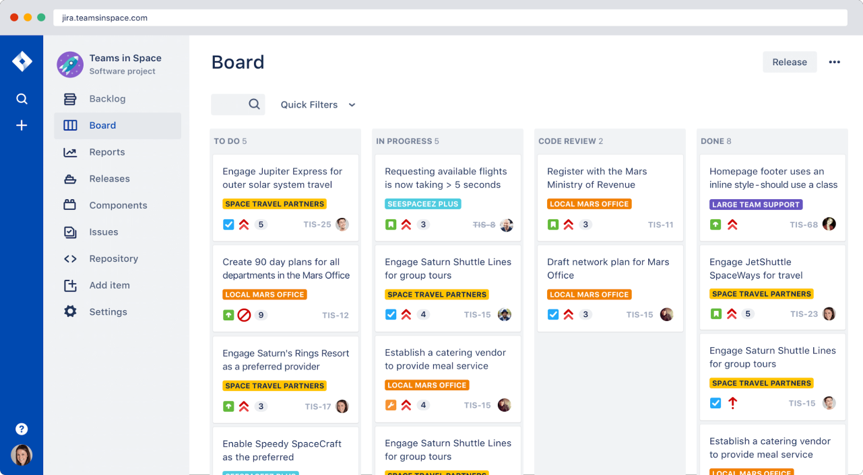

**Figure 1.1 Sample Jira Board**

###### Google Cloud

Google Cloud is a suite of cloud computing services offered by Google, including infrastructure, platform, and software-as-a-service solutions. It provides a range of tools and services for storage, compute, networking, security, artificial intelligence, and machine learning. With Google Cloud, organizations can build, deploy, and scale applications and services on a global scale, leveraging the power and reliability of Google's infrastructure. Figure 1.2 illustrates the google cloud build of an application

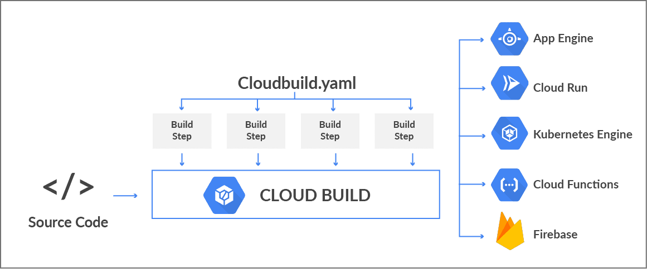

**Figure 1.2 Google cloud build**

The different features of Google cloud are as follows:

* + - * **Scalability**: Google Cloud provides a scalable infrastructure that can handle both small and large workloads. Users can easily increase or decrease resources as needed, without the need for manual intervention
      * **Integration with Other Google Services**: Google Cloud integrates seamlessly with other Google services such as G Suite, Google Analytics, and Google BigQuery. This allows users to leverage the power of Google's ecosystem and easily integrate their cloud workloads with their other business processes.
      * **Advanced Analytics Capabilities**: Google Cloud provides a range of advanced analytics tools, such as Big Query and Dataflow, that allow organizations to process and analyze large datasets quickly and easily. These tools are fully managed, meaning that users do not need to worry about infrastructure management, and can instead focus on extracting insights from their data.
      * **Hybrid Cloud Capabilities**: Google Cloud provides a range of hybrid cloud capabilities, allowing users to seamlessly integrate their on-premises infrastructure with their cloud workloads.

###### Docker

Docker is an open-source platform that allows developers to create, deploy, and run applications in containers. Containers are lightweight, portable, and self-contained environments that encapsulate an application and all its dependencies, allowing it to run consistently across different environments. Docker has revolutionized the way applications are developed, deployed, and scaled, enabling faster delivery of software and improved resource utilization. Figure 1.3 shows a docker’s architecture.

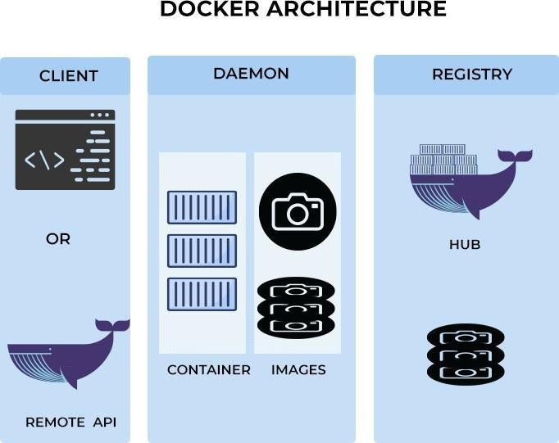

**Figure 1.3 Docker Architecture**

Docker when used to deploy apps in google cloud will give the following advantages:

* **Portability**: Docker provides a consistent environment for applications, which makes them highly portable. Developers can build an application and package it in a Docker container, which can be run on any platform that supports Docker, without any modifications.
* **Scalability**: Docker's container-based architecture allows for horizontal scaling, which means that multiple instances of the same application can be run simultaneously to handle increasing traffic. This allows for more efficient use of resources and better performance.
* **DevOps Integration**: Docker integrates seamlessly with popular DevOps tools such as Jenkins, Git, and Kubernetes, enabling a smooth development and deployment process. Docker also allows for version control of container images, which helps in maintaining consistency.

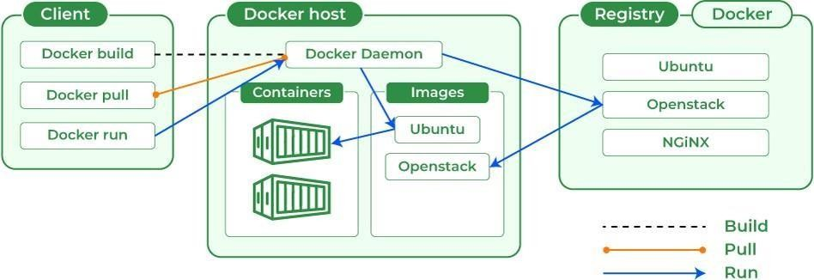

**Figure 1.4 Working of a docker with application**

###### Apache Kafka

Apache Kafka is an open source distributed streaming platform that was initially developed at LinkedIn. It provides a highly scalable, fault-tolerant, and real-time messaging system that allows for the processing of large volumes of data in a distributed and decoupled manner. Kafka is designed to handle data streams from multiple sources and make them available to different types of applications in a fast and efficient way. Figure 1.5 shows Kafka’s architecture. It has become increasingly popular in recent years for its ability to handle real-time data processing and for its seamless integration with other Big Data technologies. Kafka has become a key component in many modern data architectures and is widely used in industries such as finance, healthcare, and e-commerce.

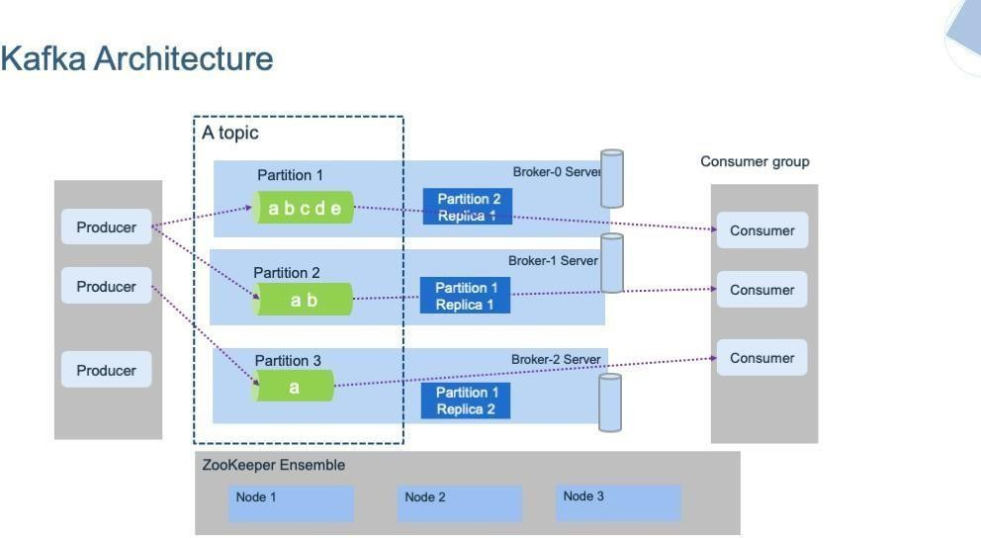

**Figure 1.5 Apache Kafka architecture**

Kafka provides a publish-subscribe messaging model where producers send messages to topics, and consumers subscribe to those topics to receive messages. Figure 1.6 shows the illustration of Kafka’s publisher subscriber model

The publish-subscribe messaging model provided by Kafka is a popular messaging pattern used in distributed systems. In this model, producers send messages to topics, which are channels of communication within Kafka. Consumers can then subscribe to these topics to receive the messages sent by the producers. This decouples the producers from the consumers, allowing for greater flexibility and scalability. Producers and consumers can be added or removed from the system without affecting the other components. Additionally, consumers can subscribe to multiple topics, and producers can send messages to multiple topics, enabling a flexible and adaptable messaging system. Kafka's publish-subscribe model provides a reliable and efficient way to process large volumes of data, making it a popular choice for modern data architectures.

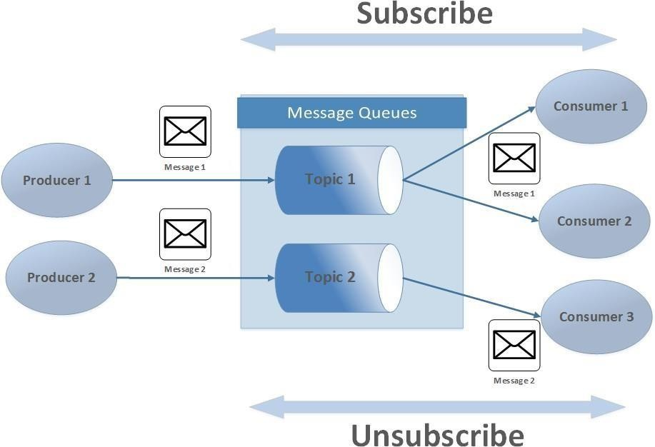

**Figure 1.6 Publisher subscriber model**

##### ANGULARJS

AngularJS, like any other front-end framework or library, is used for specific purposes, and the choice of whether to use it over other libraries depends on the requirements of the web application and development preferences. Here are some reasons to use AngularJS over other libraries:

1. **Declarative UI:** AngularJS's declarative approach to building user interfaces allows to define the desired behavior of the application in the HTML markup. This can make the code more self- explanatory and easier to maintain compared to libraries that require to manipulate the DOM manually.
2. **Two-Way Data Binding:** AngularJS's two-way data binding simplifies the synchronization of data between the model and the view, making it easier to create real-time, interactive applications without writing a lot of custom code for handling user input and data updates. AngularJS's declarative approach to building user interfaces allows to define the desired behavior of the application in the HTML markup. This can make the code more self- explanatory and easier to maintain compared to libraries that require to manipulate the DOM manually.
3. **MVC Architecture:** AngularJS follows the Model-View-Controller (MVC) architectural pattern, which enforces a clear separation of concerns. This can lead to more organized and maintainable code, especially in larger applications.
4. **Dependency Injection:** AngularJS has a built-in dependency injection system that facilitates modular and testable code. This can be particularly helpful in large projects where managing dependencies and unit testing are crucial.
5. **Rich Ecosystem:** AngularJS has a robust ecosystem with a wide range of built-in features and third-party libraries. This ecosystem can save time and effort when building complex web applications by providing tools for routing, form handling, and more.
6. **Community and Support**: AngularJS has a strong and active community, which can find extensive documentation, tutorials, and support online. This can be valuable while encountering challenges or need to learn new concepts.

Ultimately, the choice of whether to use AngularJS or other libraries depends on the specific needs and constraints of the project, the team's expertise, and the long-term goals. It's important to assess the pros and cons of each technology and select the one that best aligns with the project's requirements and the team's skills.

##### DJANGO

Django is a high-level, open-source web framework for building web applications quickly and with less code. It follows the Model-View-Controller (MVC) architectural pattern, but in Django, it's often referred to as the Model-View-Template (MVT) pattern. Below is the introduction to Django:

**Python-Based**: Django is a Python web framework. Python is known for its simplicity and readability, making Django a popular choice for developers who appreciate clean and maintainable code.

**MVT Architecture:** Django's architecture is based on the Model-View-Template (MVT) pattern. This pattern is similar to the more common Model-View-Controller (MVC) pattern but has slight differences:

* Model: Represents the data structure and business logic.
* View: Handles the presentation logic and interacts with the model.
* Template: Manages the presentation and the user interface.

**Community and Ecosystem:** Django has a large and active community, which means extensive documentation, third-party packages, and a wealth of tutorials and resources are available. This community contributes to the framework's stability and evolution.

**Django REST Framework:** For building web APIs, Django can be combined with the Django REST framework, an immensely popular and powerful toolkit for creating web APIs. This is a crucial feature when developing modern applications that require API services.

**Django Versions:** As of last update in October 2024, the latest version of Django was Django 4.x. Django continues to evolve, with regular updates and new features.

In summary, Django is a robust and highly productive web framework for building web applications in Python. Its adherence to best practices, its emphasis on reducing redundancy, and its comprehensive set of features make it a popular choice for developers aiming to create high-quality web applications efficiently.

##### MONGODB

MongoDB is a prominent NoSQL database management system renowned for its document- oriented data model. Instead of traditional tables, MongoDB stores data in flexible and hierarchical documents in BSON format. This schema-less approach allows for agile development and is particularly advantageous when handling evolving or complex data structures. The following points describe why MONGODB was preferred :-

* **Flexible Schema:** MongoDB uses a flexible schema, allowing to store data in a document

format without a fixed structure. This flexibility makes it easier to adapt to changing data requirements and accommodate evolving application needs.

* **Scalability:** MongoDB is designed for horizontal scalability which easily distribute the data across multiple servers and scale the database as the application grows. This sharding capability makes it well-suited for handling large amounts of data and high-traffic applications
* **High Performance:** MongoDB is optimized for performance. It provides fast read and write operations and supports features like indexing, aggregation, and in-memory storage options. This performance is particularly beneficial for applications with large datasets and high read/write workloads.
* **Rich Query Language:** MongoDB offers a powerful query language that allows to perform complex queries, filtering, and aggregation on the data. It supports features like geospatial queries, text search, and data aggregation pipelines, making it versatile for various application requirements.
* **Document-Oriented:** MongoDB stores data in BSON (Binary JSON) format, which is a rich and expressive way to represent data. This document-oriented approach aligns well with modern development practices, making it easy for developers to work with data in their preferred data structures, like JSON, without complex mapping.

**CHAPTER 2 PRODUCT DESCRIPTION**

A system overview provides a high-level description of the components and functionality of

a system. It serves as a roadmap for understanding how the system operates and how its various parts interact. It helps stakeholders, including developers and users, to gain a clear understanding of the system's purpose, design, and functionality.

## INTRODUCTION

In the dynamic landscape of data-driven decision-making, **Predigle Cart** emerges as a transformative force, enabling businesses to unlock the full potential of their data and convert it into actionable insights that drive revenue growth. Recognizing the critical role that data plays in modern sales operations, **Predigle Cart** empowers organizations with the tools and expertise necessary to leverage data effectively. The innovative **SalesOps Technology** revolutionizes the way front-line sales teams operate, allowing them to score the best deals for their enterprises while simultaneously enhancing customer engagement and satisfaction.

At the heart of **Predigle Cart's** value proposition lies a robust platform that simplifies the complex process of revenue operations. By applying a proprietary cohort strategy to analyze customers, prospects, and competitors, businesses can identify the right opportunities for growth. Whether optimizing pricing structures, targeting high-value prospects, or enhancing the overall customer experience, **Predigle Cart** empowers organizations to make informed, data-driven decisions that lead to increased profitability and sustained growth.

Through advanced analytics and data-driven tools, sales teams gain a deeper

understanding of the market landscape, enabling them to identify areas for improvement and

capitalize on emerging trends. By investing in the right technology and expertise, organizations can overcome the challenges of competitive pricing and achieve sustainable growth, ensuring they remain agile and responsive in today's fast-paced business environment.

**PI Optima** is a cutting-edge platform designed to help businesses optimize their marketing and trade activities by leveraging real-time learning models. The platform analyzes the impact of various factors, such as marketing campaigns, trade activities, and external environmental influences, on business volume. By providing actionable insights, **PI Optima** empowers companies to make data-driven decisions that align with their financial goals.

## OBJECTIVE

The objective of **Predigle Cart** is to revolutionize sales operations by equipping front-line sales teams and managers with the tools needed to make data-driven decisions that maximize sales performance. By utilizing a proprietary cohort strategy, the platform enables businesses to analyze customer behavior, market trends, and competitive positioning. This data helps identify key prospects, optimize product recommendations, and fine-tune pricing strategies based on demand-supply insights.

Through real-time market intelligence and dynamic targeting, **Predigle Cart** supports meaningful customer engagements, ensuring timely interventions that drive higher order values and improve profit margins. The platform also facilitates strategic customer segmentation, allowing sales teams to develop tailored approaches for different customer groups. By integrating all these elements, **Predigle Cart** empowers businesses to enhance their sales strategies, strengthen customer relationships, and achieve sustained growth in a competitive marketplace. Fig 2.1 shows the workflow of the cart application.

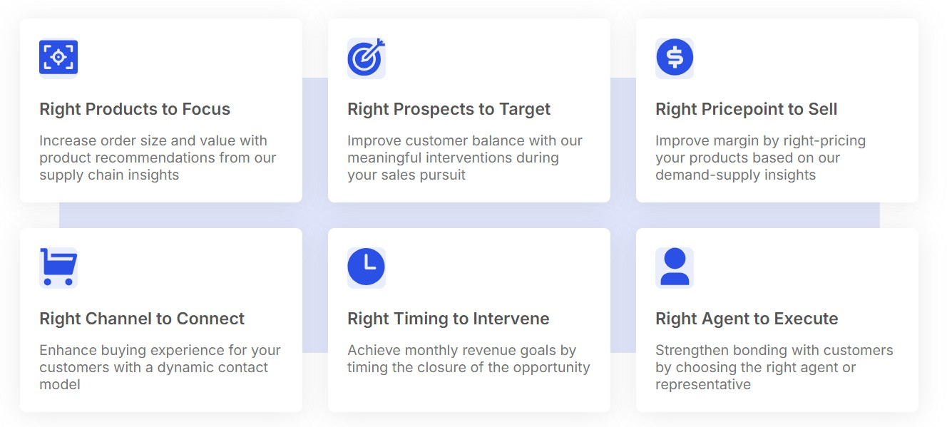

**Figure 2.1 Predigle Cart - Sales Optimization Workflow**

The primary objective of **PI Optima** is to enable businesses to strategically plan their activities and allocate budgets in a way that maximizes financial outcomes. By identifying key drivers of volume impact and guiding the development of optimized plan scenarios, **PI Optima** helps businesses achieve specific financial objectives with precision and efficiency. This targeted approach ensures that resources are deployed effectively to meet revenue and growth goals.

## FEATURES

The following subsection outlines the important features of the product in detail.

#### Predigle Cart

**Predigle Cart** is not only a sales tool but also a comprehensive ecosystem that transforms the way businesses approach sales operations and decision-making. Here’s what sets Predigle Cart apart:

#### Intuitive Web and App Interface for Predigle Cart:

Predigle Cart offers an intuitive and user-friendly interface, available on both web and mobile platforms, designed to streamline the sales and product management processes. The customizable dashboard allows users to tailor their workspace to meet specific needs, whether they are working on sales, product mapping, or competitor analysis. This flexibility ensures that users have easy access to the most relevant features and data, enhancing productivity and decision-making. Fig 2.2 illustrates the main home page of the cart web application and Fig 2.3 represent the home page of the ipad application

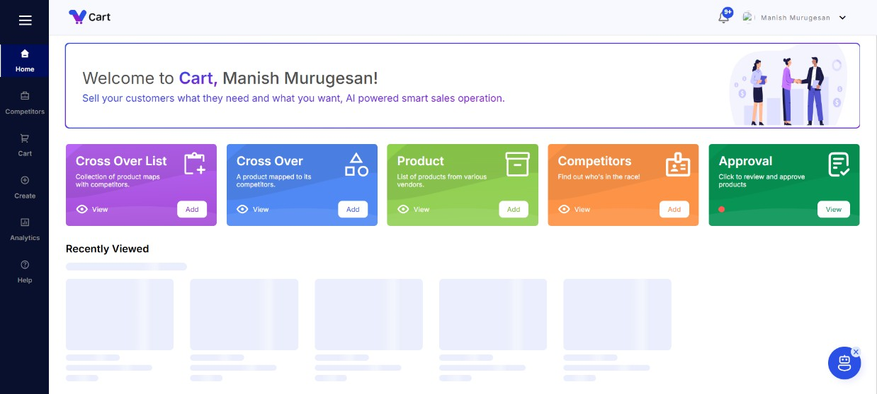

**Figure 2.2 Home page**

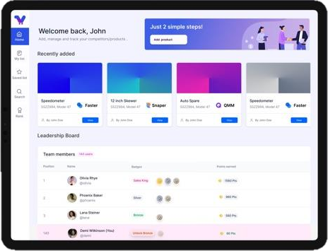

**Figure 2.3 Ipad App Home page**

#### User Authentication with Keycloak

Predigle Cart integrates Keycloak for secure and streamlined user authentication, providing an efficient solution for managing access in a business-to-business (B2B) environment. This integration allows users to authenticate using their email addresses and passwords, offering a smooth and secure login experience. With Keycloak’s powerful identity and access management features, administrators can easily manage user roles, permissions, and access levels, ensuring that each user has the appropriate access to Predigle Cart's resources.

This is particularly beneficial when handling multiple users across different organizations, as Keycloak simplifies the process of onboarding new users and configuring their access rights based on the specific needs of each business. By leveraging Keycloak, Predigle Cart ensures that sensitive data is protected, and only authorized users can access critical features, enhancing the platform’s overall security and usability. Fig 2.4 is the main authentication page for the cart application.

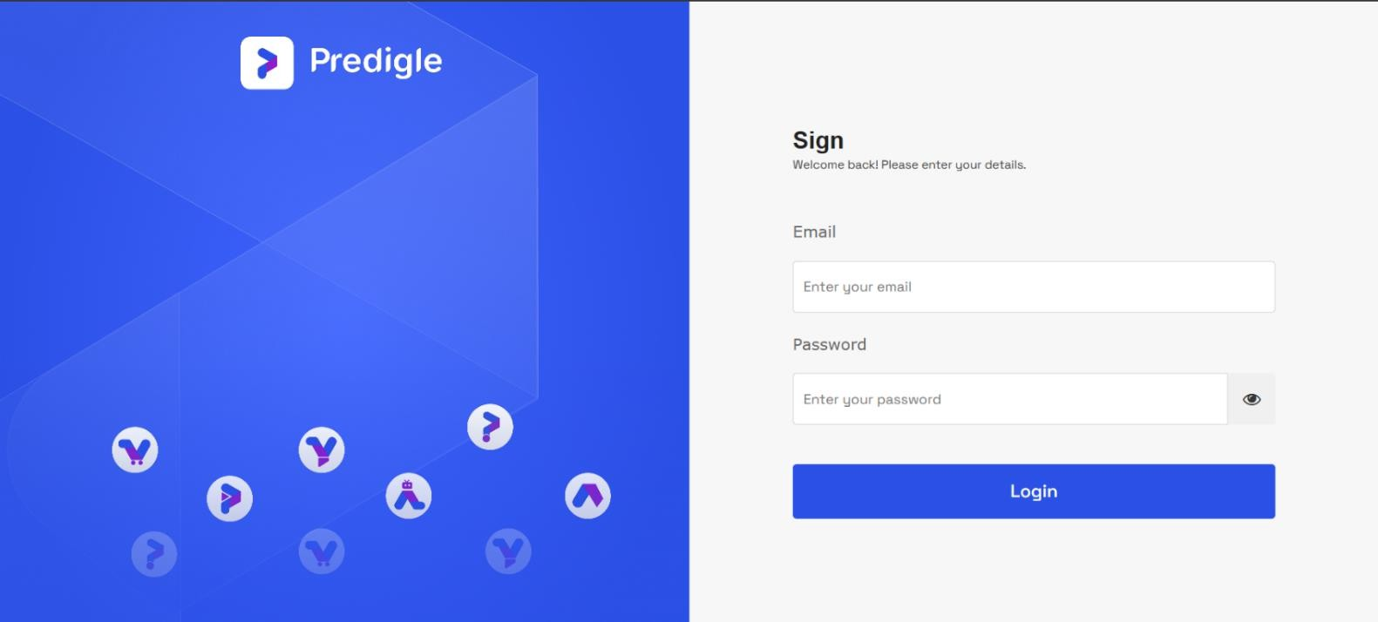

**Figure 2.4 Keycloak Authentication Page**

#### Cross Over List

The **Cross Over List** feature offers a unique advantage to sales teams by presenting a collection of products mapped to their competitors. This mapping helps businesses not only understand how their offerings stack up against the competition but also spot opportunities to emphasize their strengths. Sales representatives can instantly view these product comparisons, helping them close deals with compelling product positioning that meets customer needs and surpasses competitor weaknesses. Fig 2.5 illustrates the crossovers listed with the productmaps grouped by the client.

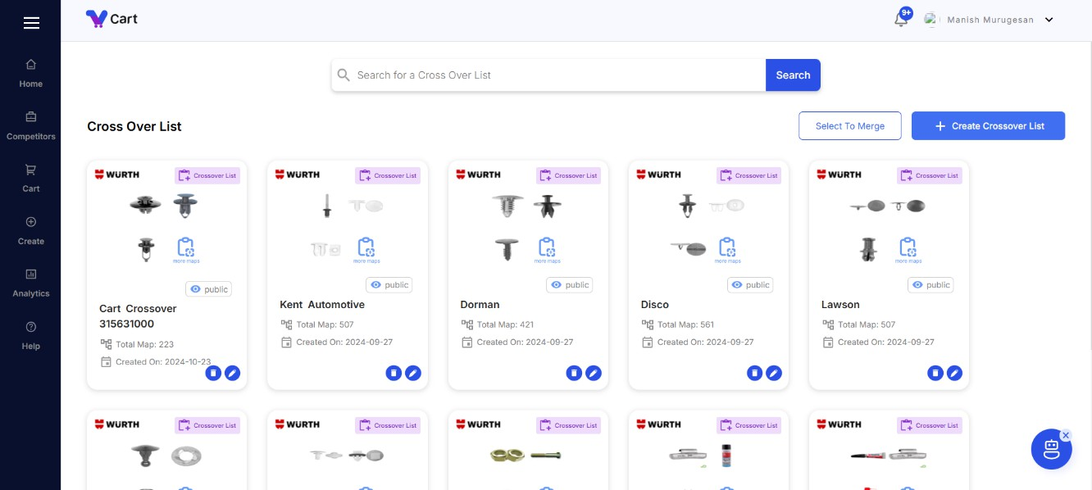

**Figure 2.5 Crossover List Feature**

#### Streamlined Product Management and Competitive Advantage

Predigle Cart centralizes product details across multiple vendors, simplifying access for sales teams to updated product information and enabling the addition of new products when necessary. This streamlined approach allows teams to quickly respond to customer inquiries and provide accurate product recommendations while maintaining control over a wide range of inventory options. The Competitors module keeps sales teams informed about market dynamics by monitoring competitors’ strategies and offerings, allowing sales managers to proactively adjust their approaches and effectively communicate differentiators during customer engagements. This real-time tracking of competitor information ensures teams stay ahead and capitalize on market opportunities. Additionally, the Approval feature guarantees that products are vetted and approved before reaching customers, safeguarding quality and consistency in the product lineup. With easy-to-manage approval workflows, sales teams can focus on their core tasks, while management ensures that offerings align with company standards.

#### AI-Driven Intelligent Alerts

Predigle Cart’s core strength lies in its **AI-driven intelligent alerts**. These real-time alerts are based on customer behaviors, market conditions, and past interactions, providing sales teams with actionable insights on when and how to engage. The platform doesn’t just deliver data; it delivers recommendations. This intelligence makes every outreach more targeted, timely, and relevant,

significantly increasing the likelihood of successful deals.

#### Dynamic Pricing Optimization and Real-Time Market Intelligence

Dynamic Pricing Optimization is a crucial capability of the Predigle platform, leveraging real-time demand-supply insights to help businesses identify the ideal price point for their products. The AI continuously analyzes market conditions to ensure that prices remain both competitive and profitable, optimizing revenue streams while maintaining market relevance. This dynamic pricing model enables businesses to stay agile and respond swiftly to market fluctuations. Complementing this, Predigle Cart offers real-time market intelligence, equipping sales teams with the latest data, trends, and competitor insights necessary for instant strategy adjustments. Whether identifying new opportunities or adapting to shifts in customer demand, the real-time intelligence provided by Predigle Cart ensures that sales strategies are always relevant and data- driven.

#### PI Optima

PI Optima goes beyond traditional analytics, offering a transformative platform that reshapes how businesses plan and execute their marketing and trade operations. Here's why PI Optima stands out:

#### Scenario List and Navigation

The application is designed to streamline the management of business activities and strategies through a central hub for scenarios. The Scenario List acts as a powerful tool that allows users to easily browse and navigate through various scenarios that their organization or business team is working on. Each scenario includes multiple related activities. Users can click on specific scenarios to access these activities, promoting a clear understanding of how different activities contribute to the overarching goals of the scenario.

This hierarchical design ensures that businesses can explore the **relationships between scenarios and their activities**, offering transparency and ease of navigation for better scenario planning. Whether managing a marketing campaign, a sales promotion, or a project plan, the intuitive interface helps users keep track of each scenario and its related activities effortlessly.

#### Independent Activities Management

In addition to scenarios, the application offers users the flexibility to create and manage activities that exist independently of any scenario. Some activities or tasks may not necessarily fit into a pre-defined scenario but are still essential for business operations. This independent activity feature is essential for users looking to operate more flexibly and manage standalone tasks that don’t need to be part of a broader project or scenario.

A **dedicated screen** is implemented to allow users to **view and edit these activities**, giving them the ability to manage business tasks more freely without the need for rigid planning structures. This screen provides a streamlined interface where all independent activities can be reviewed, updated, and analysed.

#### Activity Creation with Visual Insights User Authentication with Keycloak

One of the standout features of the application is the ability to create new activities that are visually represented for better clarity. Users can enter critical details for new activities, which are then stored in the backend through API integrations. This ensures that the data is securely transmitted and stored, supporting robust data management practices.

To enhance user experience and assist in decision-making, each activity is presented with a **visual chart** powered by the Highcharts library. This chart provides a visual representation of relevant data, such as pricing trends, volume changes, and profit margins, depending on the activity's context. Visual insights help users quickly understand complex data, making it easier to

make data-driven decisions and monitor the potential success of their activities in real-time.

#### User Authentication with Keycloak

PI Optima integrates Keycloak to offer a secure and efficient solution for user authentication, particularly in a B2B environment. This integration ensures that users can log in using their email addresses and passwords, providing a seamless and secure experience. With **Keycloak’s role-based access control**, administrators can manage user roles, permissions, and access levels effortlessly. This ensures that users only have access to the features and data relevant to their roles, enhancing both security and usability.

Keycloak's flexibility is especially valuable in managing multiple organizations, simplifying onboarding and access configuration. As PI Optima scales, Keycloak ensures that sensitive data remains protected, while authorized users can efficiently access the necessary tools.

**CHAPTER 3 PERSONAL CONTRIBUTION**

This chapter provides details on contribution to the implementation of the previously mentioned products.

## CODE REVAMPING

The codebase has been significantly revamped to enhance clarity and reduce redundancy, making it more understandable and easier to modify. A mixin structure for styling was implemented, ensuring consistency by aligning with Material UI guidelines. Additionally, data extraction processes within API calls were optimized, resulting in reduced response times and improved system efficiency. API-related page load issues were resolved and completed a comprehensive design revamp of the Product Request page, creating a more intuitive interface that streamlines user interactions. These improvements contribute to a more robust and maintainable application overall.

Substantial amount of effort towards understanding the user perspective and enhancing the overall quality of the software. This includes a comprehensive analysis of user- reported bugs and issues, along with proactive bug identification, to ensure that the application remains smooth and error-free. By delving into the user experience, pain points and areas of frustration were addressed, ultimately leading to a more satisfied user base.

## LIST AND GRID VIEW IMPLEMENTATION

The newly implemented view-only mode page for the Product Map List feature provides users with a comprehensive and intuitive interface designed to enhance their experience while

ensuring data integrity. In this mode, users can access product maps displayed in both grid and table views, allowing for flexible and convenient navigation of the available information.

In the view-only mode, all fields and options related to editing or changing product maps are disabled, preventing any modifications to the data. Users can view detailed information about each product map, including attributes like name, description, and associated vendors, but they are unable to make any changes directly on this page. This design choice prioritizes the accuracy and stability of the data, ensuring that only authorized personnel can make updates.

If users wish to modify a product map, they can easily initiate a request through an embedded feature within the page. This request functionality prompts users to specify the changes they need, and the system automatically forwards their request to the respective person or team authorized to grant permission. By streamlining the request process, users can efficiently communicate their needs without compromising the integrity of the product map data. Fig 3.1 illustrates the table view and Fig 3.2 illustrates the grid view of different product maps listed with its details.

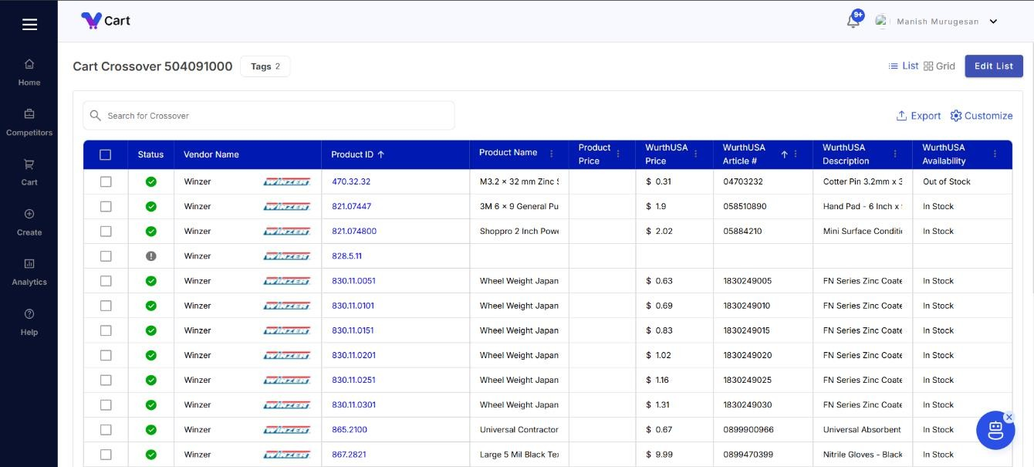

**Figure 3.1 Table list-view-only-mode**

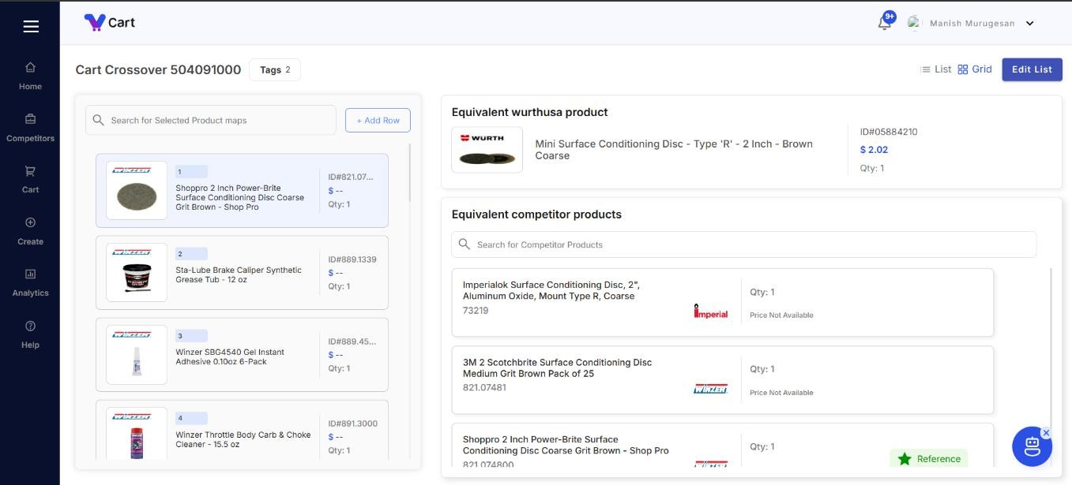

**Figure 3.2 Table grid-view-only-mode**

## ACCEPT DECLINE FEATURE WITH PRODUCT CARD

The enhancement of the Stage Product feature now includes fully functional Product Cards and Challenge Points Cards, significantly boosting user engagement. Products in a pending state can be accepted either as standard offerings or as crossover options, with the user who submitted the product earning points based on the decision. Each product card displays its status—accepted, declined, or pending—along with details about who made the decision, promoting transparency in the approval process.

Additionally, the feature incorporates a live-fetch capability that retrieves and displays equivalent products for each submitted item in real time. This allows users to access comparable options instantly, facilitating informed decision-making. Overall, these improvements streamline product management while enhancing user interaction and reward systems within the application. Fig 3.3 shows the product request page with product status and the equivalent product details as cards.

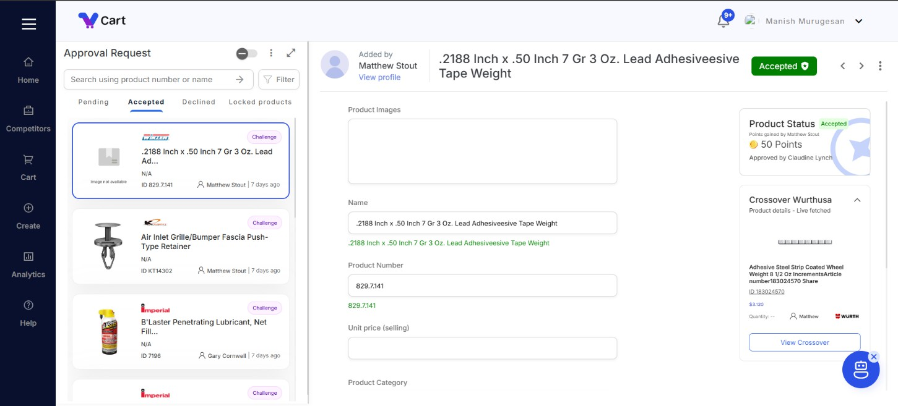

**Figure 3.3 Accept Decline Feature**

## PI OPTIMA FRONTEND SETUP

The new frontend project was established with a comprehensive setup for local, development, and production environments, featuring environment-specific variables and API endpoints for seamless transitions between stages. Successful integration with the backend project was achieved, enabling basic initial APIs for effective data communication.

A robust frontend architecture was developed, emphasizing clear organization and maintainability. This architecture includes well-defined models for data structures and a hierarchical component structure that promotes reusability and modular design. Additionally, primary and secondary styles were defined, along with mixins to ensure consistent styling across components. This setup provides a solid foundation for future development, making the application scalable and maintainable while enhancing the overall user experience.

## ROUTING SETUP AND BREADCRUMB NAVIGATION

In the first iteration of the application, basic routes were defined to establish a clear navigation structure, enhancing user experience and accessibility. The routing setup includes key paths for various components, allowing users to navigate seamlessly between different sections of the app.

To improve performance and optimize loading times, a lazy loading strategy was implemented for the routes. This approach ensures that modules are loaded only when they are needed, reducing the initial load time and improving the application's responsiveness.

Additionally, breadcrumb navigation was integrated into the routing architecture. This feature provides users with a visual trail of their navigation path, making it easier to understand their current location within the app and enhancing overall usability.

The architecture of the routing system maintains a clean and organized structure, facilitating future expansions and modifications. This foundational setup sets the stage for scalable development as the application evolves. Fig 3.4 illustrates the breadcrumb navigation for creating new activity.



**Figure 3.4 Breadcrumbs implementation**

## ACTIVITY & SCENARIO MANAGEMENT SCREENS

The Scenario List functions as a central hub where users can easily view and navigate through various scenarios, each encompassing multiple activities. By clicking on a specific scenario, users can delve deeper into its associated activities, allowing for a streamlined exploration of the relationships between scenarios and their respective tasks. This design fosters a cohesive understanding of how different scenarios interconnect, enhancing user engagement and interaction with the application. Fig 3.5 illustrates and the table view of different scenarios.

In addition to their role within scenarios, activities can also exist independently, providing users with the flexibility to create and manage activities without being constrained to a particular scenario. To support this functionality, a separate screen was implemented for viewing and editing activities, enabling users to focus on individual tasks and modifications without navigating through scenarios. Fig 3.6 illustrates the table view of different activities

To facilitate the creation of new activities, a feature was developed that allows users to input essential details, which are then stored in the backend via APIs. This process ensures that all activity data is efficiently managed and retrievable. To enhance the user experience further, each activity includes a visual representation of relevant data through charts executed using the High charts library. These visual aids offer users clear and insightful data representations, supporting better decision-making by making complex information more accessible and understandable. Fig 3.7 contains the page where new activity to be created.

Overall, this comprehensive system enhances both the organizational structure of scenarios and activities while providing valuable tools for users to manage and analyse their tasks effectively. By combining intuitive navigation, independent activity management, and dynamic visual representations, the application significantly improves the user experience and operational efficiency.

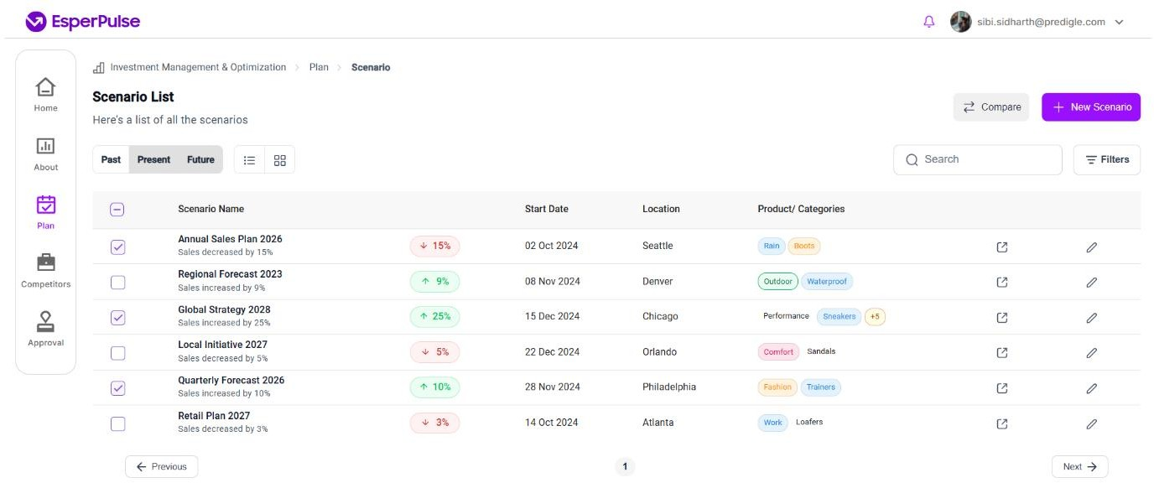

**Figure 3.5 Scenario List Screen**

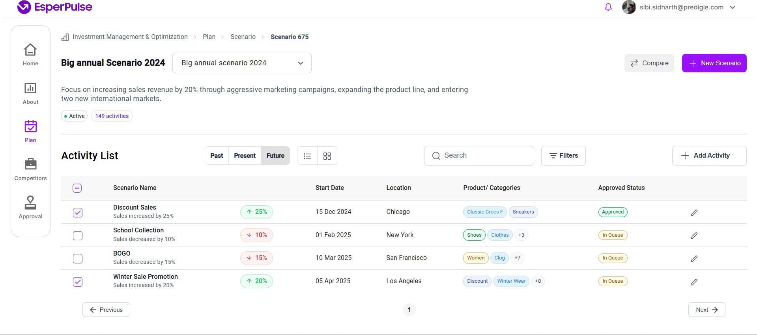

**Figure 3.6 Activity List Screen**

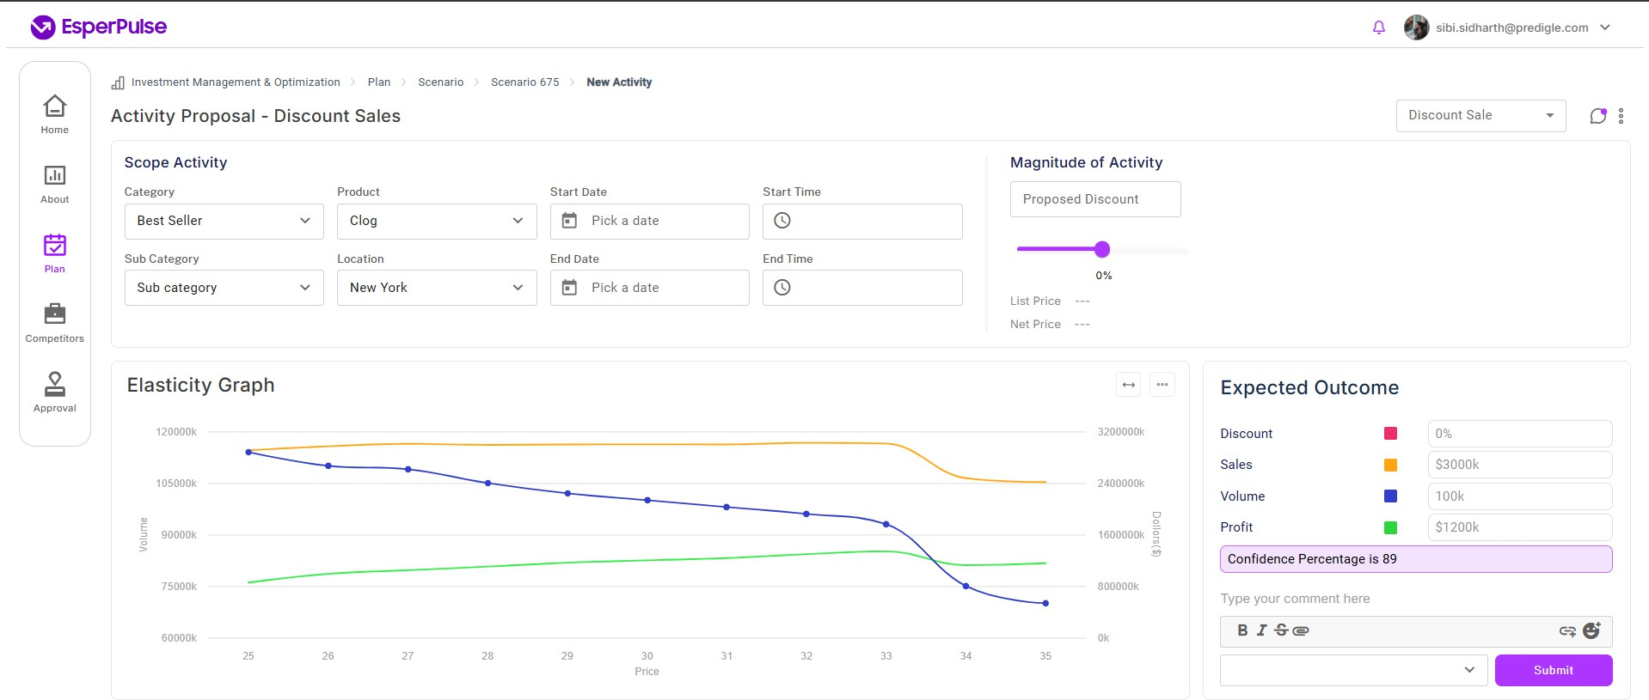

**Figure 3.7 New Activity Screen**

**CHAPTER 4 SYSTEM TESTING**

System testing is a generic metric of performing a variety of tests on a system to explore functionality or to identify problems. A series of systematic procedures are referred to test how the system should perform and where common mistakes may be found by entering data that may cause the system to malfunction or return incorrect information. The purpose of testing is quality assurance, verification and validation, or reliability estimation. A Test Plan documents the strategy that will be used to verify and ensure that a product meets its design specifications.

## TEST CASES

Test cases are built around the requirements and specifications i.e., what the system is supposed to do. Tables given below contains the various test cases and their reports. Each test case contains item criteria such as:

* + - PASS - All expected results are achieved, and/or all unexpected events are resolved.
    - PASS WITH EXCEPTIONS - Unexpected events require alternative procedures that have been implemented and those events are called Exceptions.
    - FAIL - Testing process response does not confirm the expected result Table 4.1 shows certain test case scenarios and their steps to pass the tests

|  |  |  |  |
| --- | --- | --- | --- |
| **Test**  **Scenario** | **Test Steps** | **Expected Outcome** | **Result** |
| Product Addition | Add a new product with the necessary details filled in he form and submitting it. | A new Product to be added in the producmap database with pending status. | PASS |
| Accept_or_Decline | The product in the pending status to either be accepted or declined based on the details provided | The product will be moved to product entity if it is accepted or will be reverted back with  decline status. | PASS |
| Bulk creation | A Bulk productmap will be uploaded in excel format with details filled | A bulk create of many productmap in it forms a productmap list | PASS |
| Notification | Any triggering actions like comments, accept/decline of products to be triggered by  necessary action | There will be a mail sent to the tagged person along with in app notification. | PASS |
| Data received via API | By calling necessary backend API via proper function and  integration | The data is received and will be displayed in the UI for  further process. | PASS |

**Table 4.1 Test Scenarios and their Result**

## TEST PLAN

This testing strategy provides a structured approach to ensure software quality and reliability. It covers all critical aspects, including the scope of testing, essential functions, testing techniques, and tools. By addressing each area thoroughly, the strategy aims to deliver a defect-free, user-friendly application that meets specified requirements and performs optimally.

## TEST SCOPE

Every functionality of the proposed application is considered as important and need to be tested for the good working of the application. So, all the functionalities will come under the in- scope of the system. The scope of testing the application is to make the developers understand the bugs, errors that are occurring in the application. It is also to solve the problems that may occur during the usage, or at least identify the errors and give a detailed 8recommendation of best practices to the users to minimize the error while operating the application.

* 1. **TESTING FUNCTIONS**

Test functions or issue means that a testing issue to apply on software to achieve quality.

All the functional features specified in the requirement analysis are to be tested.

The testing functionalities are:

* + - Authorization
    - Data integrity
    - System reliability
    - System security
    - Response time of the system
    - Overall efficiency

## TEST TECHNIQUES

Testing techniques are structured methods used to validate the functionality, performance, and integration of application components, ensuring they meet expected standards and work seamlessly together.

###### Unit Testing

Unit testing is defined as testing the individual chunks of code prepared by developers using useful and valid data. It usually has one or a few inputs and usually a single output.

###### UI Testing

In UI testing, all visual elements which interacts with the users of the application is tested to meet the expected performance and this is tested using different device screens.

###### Integration Testing

Integration testing is used to combine different pieces of modules and check whether they are working as a group. The purpose of this level of testing is to expose faults between integrated units. that verifies the interaction between different components or modules of an application. Thepurpose of integration testing is to ensure that these components work together seamlessly and that any issues or bugs in their interaction are identified and resolved before the final product is delivered to the end- users.

**CHAPTER 5 SYSTEM IMPLEMENTATION**

Implementation is the process of converting a new or a revised system design into an operational one. It is the most crucial stage in achieving a new successful system and in giving confidence to the new system for the teams that it will work efficiently and effectively. In this phase, one can build the components either from scratch or by composition. Given the architecture document from the design phase and requirement document from the analysis phase, one can build exactly what has been requested.

## IMPLEMENTATION PROCEDURE

Implementation procedure refers to the process of putting into action or executing a plan or idea. It involves taking the necessary steps to ensure that a project or initiative is carried out successfully.

###### Prerequisite:

In prerequisite, Visual Studio Code along with plugin of angular is installed. PostgreSQL is installed for manipulating tables of the database.

###### Visual Studio Code

* + 1. Install Visual studio Code (1.94)
    2. Download an .exe file.

The following steps must be followed to complete the installation,

1. Installing angular
   1. Install Node/npm
   2. Use and install Angular CLI globally
   3. Run Angular CLI commands
2. To install all required packages
   1. npm install
3. Navigate to the root folder of the Codebase
   1. npm start

.

###### Start the back-end server

Run the configured server (Figure 5.1 shows the running of the backend server)

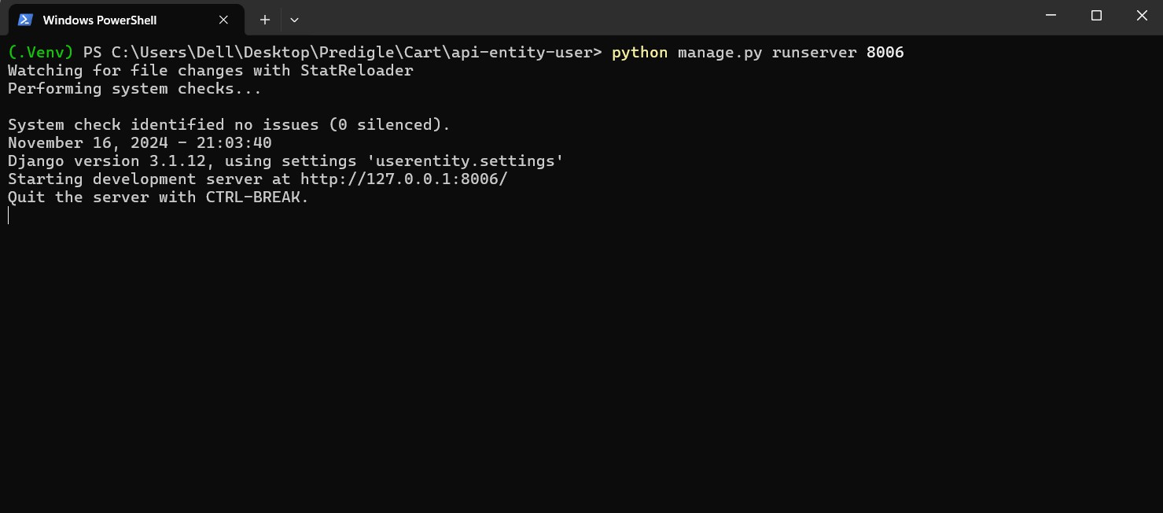

**Figure 5.1 Starting the Business API to communicate all competitor related info to the backend**

**CHAPTER 6 CONCLUSION**

In conclusion, **Predigle Cart** serves as a transformative ally in the realm of data-driven sales operations, empowering businesses to harness the full potential of their data and convert it into strategic advantages. With a steadfast commitment to driving revenue growth, providing a cutting-edge SalesOps Technology platform that simplifies the complexities of optimizing sales strategies. By leveraging intelligent insights and advanced analytics, enabling organizations to make informed decisions, enhance customer engagement, and streamline their operations. In a competitive landscape where data is essential for success, Predigle Cart stands as the trusted partner that equips businesses with the tools and expertise to achieve sustainable growth and unlock new opportunities for prosperity.

**PI Optima** empowers businesses to make data-driven decisions by leveraging real-time learning models that assess the impact of marketing, trade activities, and environmental factors. With features like scenario planning, independent activity management, and visual data representation, it provides a comprehensive platform for optimizing strategies and achieving financial objectives. Its secure, scalable design ensures a seamless and consistent user experience, making it an invaluable tool for businesses aiming to streamline their operations.

# BIBLIOGRAPHY

## Websites

* <https://predigle.com/>
* <https://predigle.com/products/>cart
* <https://angular.io/start>
* <https://www.docker.com/products/developer-tools/>
* <https://cloud.google.com/docs>